**C++**

“C++ is a statically-typed, free-form, (usually) compiled, multi-paradigm, intermediate-level general-purpose middle-level programming language.”

In simple terms, C++ is a sophisticated, efficient and a general-purpose programming language based on C. It was developed by Bjarne Stroustrup in 1979.

Many of today’s operating systems, system drivers, browsers and games use C++ as their core language. This makes C++ one of the most popular languages today.

Since it is an enhanced/extended version of C programming language, C and C++ are often denoted together as C/C++.

**History of C++**

While Bjarne Stroustrup was working in AT&T Bell Labs in 1979, he faced difficulties in analyzing UNIX kernel for distributed systems. The current languages were either too slow or too low level. So, he set forward to create a new language.

For building this language, he chose C. Why C? Because it is a general purpose language and is very efficient as well as fast in its operations.

He used his knowledge of object-oriented model from SIMULA and began working on class extensions to C. His aim was to create a language with far higher level of abstraction while retaining the efficiency of C.

This new programming language was named C withClasses, but was later renamed to C++ (++ refers to the increment operator in C).

**C++98**

When C++ was first released in 1985, there were no official standards released. It was only until 1998 that C++ was first standardized which was known as C++98.

**C++03**

In 2003, a new version of C++ standard was published. C++03 wasn’t really a new standard altogether but a bug fix release identified with C++98 “**to ensure greater consistency and portability**”.

**C++11 (C++0x)**

The next major standard for C++ was released in 2011 and it was named C++11. Since, C++ committee was sure this update would be released within 2009, they unofficially named it C++0x. Later, when they didn’t, Stroustrup joked that C++0x went hexadecimal - C++0xB (C++11). Nice save.

**C++14 (C++1y)**

C++14 is the current iteration of C++ released in 2014. Like C++03, it included mainly bug fixes and simple improvements to C++11.

**C++17 (C++1z)**

The supposedly next iteration to C++ which is planned to be rolled out in 2017. It is expected to have many new features. Most of the features planned for this version are already completed.

### Run C++ in Windows (XP, 7, 8 and 10)

To run C++ Programming in Windows, you’d need to download Code::Blocks.

There are others available as well but Code::Blocks makes installation a piece of cake.

It’s easy, simple and developer friendly.

To make this procedure even easier, follow this step by step guide.

1. Go to the [binary release download page of Code:Blocks](http://www.codeblocks.org/downloads/26) official site.  
   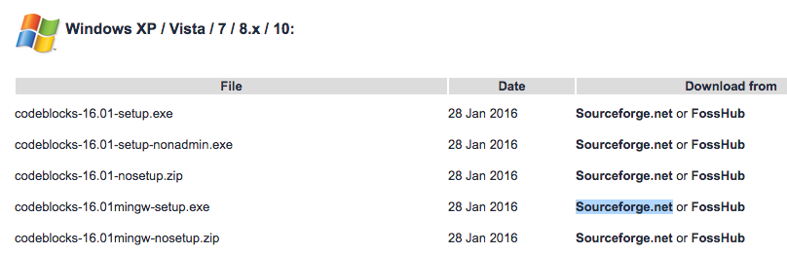
2. Under **Windows XP / Vista / 7 / 8.x / 10** section, click the link with **mingw-setup** highlighted row either from Sourceforge.net or FossHub.
3. Open the Code::Blocks Setup file and follow the instructions (**Next** > **I agree** > **Next** > **Install**); you don’t need to change anything. This installs the Code::Blocks with gnu gcc compiler, which is the best compiler to start with for beginners.
4. Now, open Code::Blocks and go to **File > New > Empty file** (Shortcut: **Ctrl+Shift+N**)  
   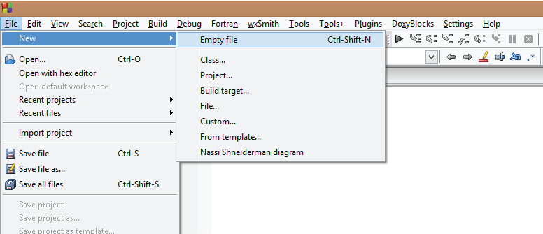
5. Write the C++ code and save the file with **.cpp** extension. To save the file, go to **File > Save** (Shortcut: **Ctrl+S**). **Important**: The filename should end with .cpp extension, like: hello**.cpp,** your-program-name**.cpp  
   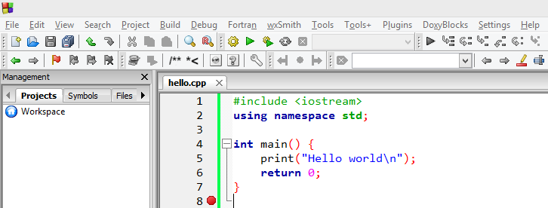**
6. To run the program, go to **Build** > **Build and Run** (Shortcut: **F9**). This will build the executable file and run it.

If your program doesn’t run and if you see error message "can't find compiler executable in your search path(GNU GCC compiler)",  go to **Settings > Compiler > Toolchain executables**  and click **Auto-detect**. This should solve the issue in most cases.